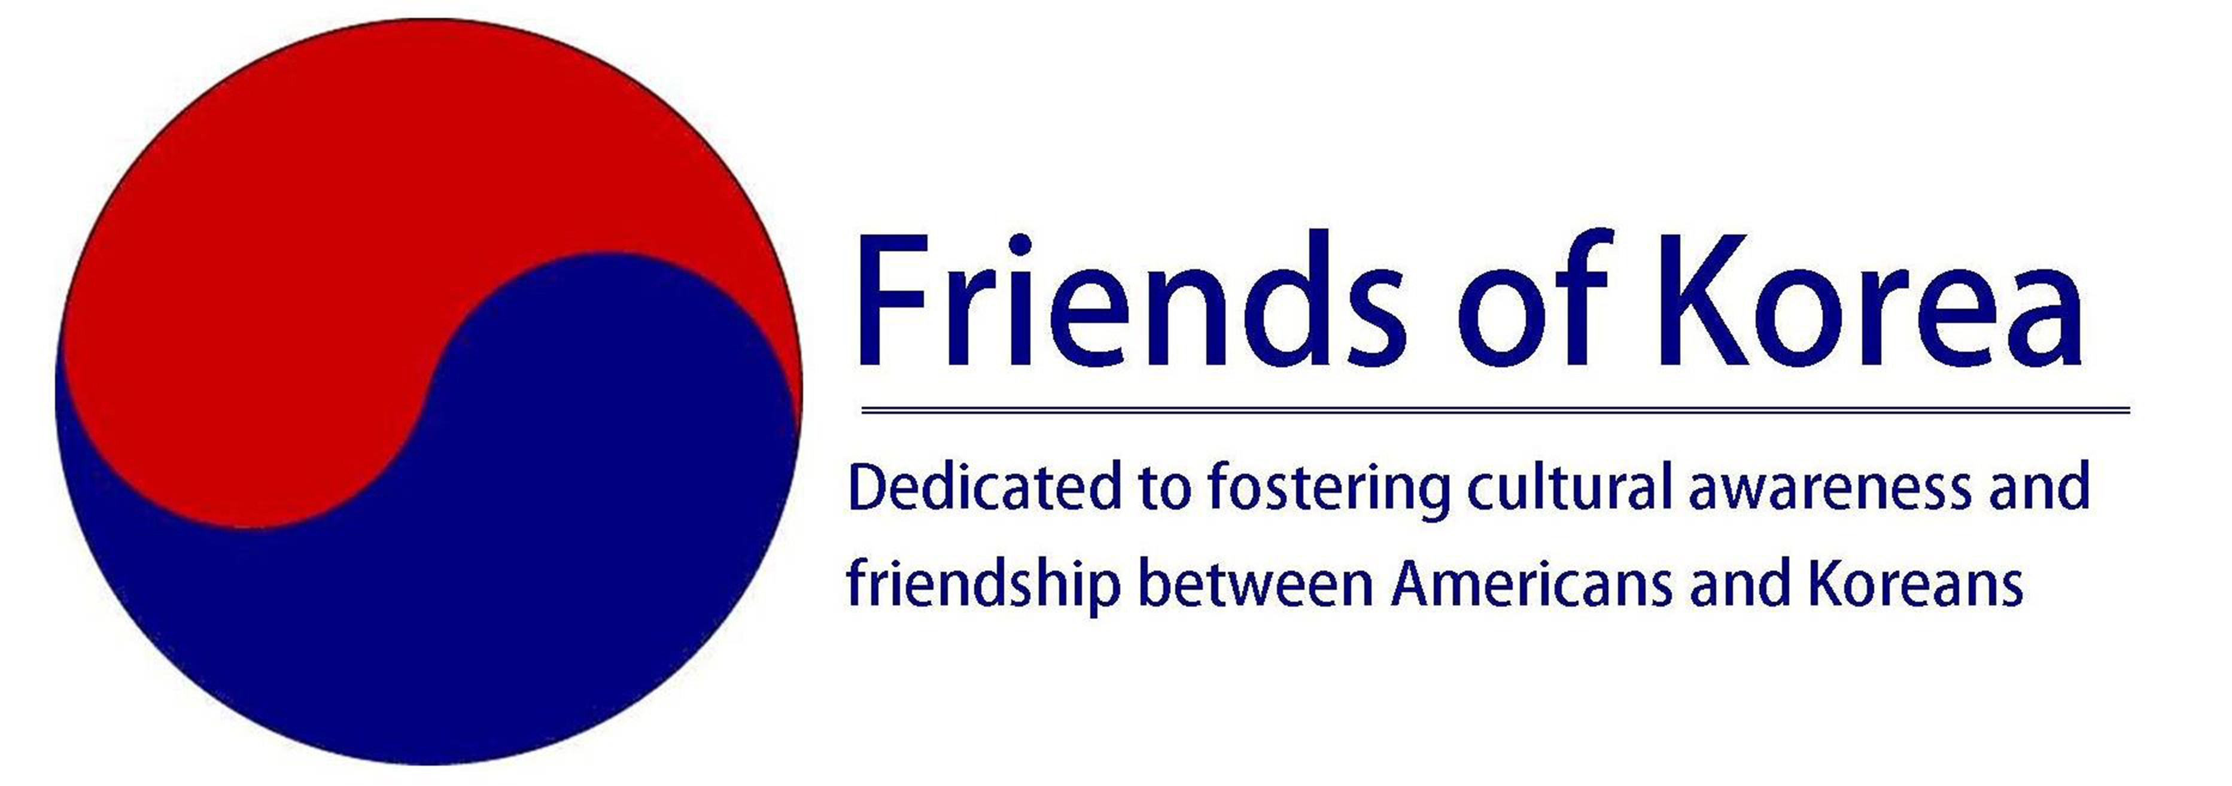

KEVIN O’DONNELL
DISTINGUISHED FRIEND OF KOREA AWARD
한국의 친구들 주최 케빈오단넬 기념상 수상자 추천절차
NOMINATION PROCEDURES

The Award
The Kevin O’Donnell Distinguished Friend of Korea Award recognizes individuals or organizations distinguished by their accomplishments that are consistent with the overarching mission of Friends of Korea: to foster cultural awareness and friendship between Americans and Koreans. The award is a lasting tribute to the extraordinary contributions made by Kevin O’Donnell, the U.S. first Peace Corps country director in Korea and the fourth director of the Peace Corps. For more information, see the FOK website.

Award Criteria
The nominee for the Kevin O’Donnell Distinguished Friend of Korea Award should have contributed significantly in fostering cultural awareness and friendship between Americans and Koreans in public service, business, religion, education, government and/or the arts. When making your nomination, please provide a statement describing how the nominee meets the award criteria, as described below.

How to nominate
Any current FOK member may recommend recipients for this recognition. You may not nominate yourself or a relative for this award.

Send your completed nomination by email to:
contact@friendsofkorea.net

or mail to:
The Award Committee
Friends of Korea
2021 L St, NW, Suite 101-403
Washington, DC 20036

Applications close
No more than one award per year will be selected. The deadline for submitting nominations for the 2018 award is June 16, 2018.

Nominee details
For Individual:
Full name
Address:
Telephone:
Email address:
Name of organization (if applicable) where the nominee contributed to mutual understanding and friendship between Americans and Koreans:

For Organization:
Name of Organization:
Type of legal entity:
Address:
Contact person:
Telephone:
Email address:

Nomination Narrative Statement
Please provide a narrative statement of up to 1,000 words setting forth the contributions of the person or organization you propose to be recognized. Please include a brief outline of the career of the nominee, focusing on connections with Korea. You may wish to describe in some detail the nominee’s contributions through activity/activities related to the Friends of Korea’s mission of fostering cultural awareness and friendship between Americans and Koreans in areas such as public service, business, religion, government or the arts. If appropriate, you may discuss the nominee’s demonstrated qualities (attitude, initiative, personal and material contribution, innovation) in supporting the goals of Friends of Korea, and to highlight any obstacles which the nominee may have had to overcome to achieve their successes.

Where possible, provide examples to support your statements.

Please also provide the following information about yourself:

Nominator Name:
Organization (if applicable)
Address:
Telephone:
Mobile:
Email:
Relationship (if any) to nominee:
Signature:
Date:

Rev: January 2018

